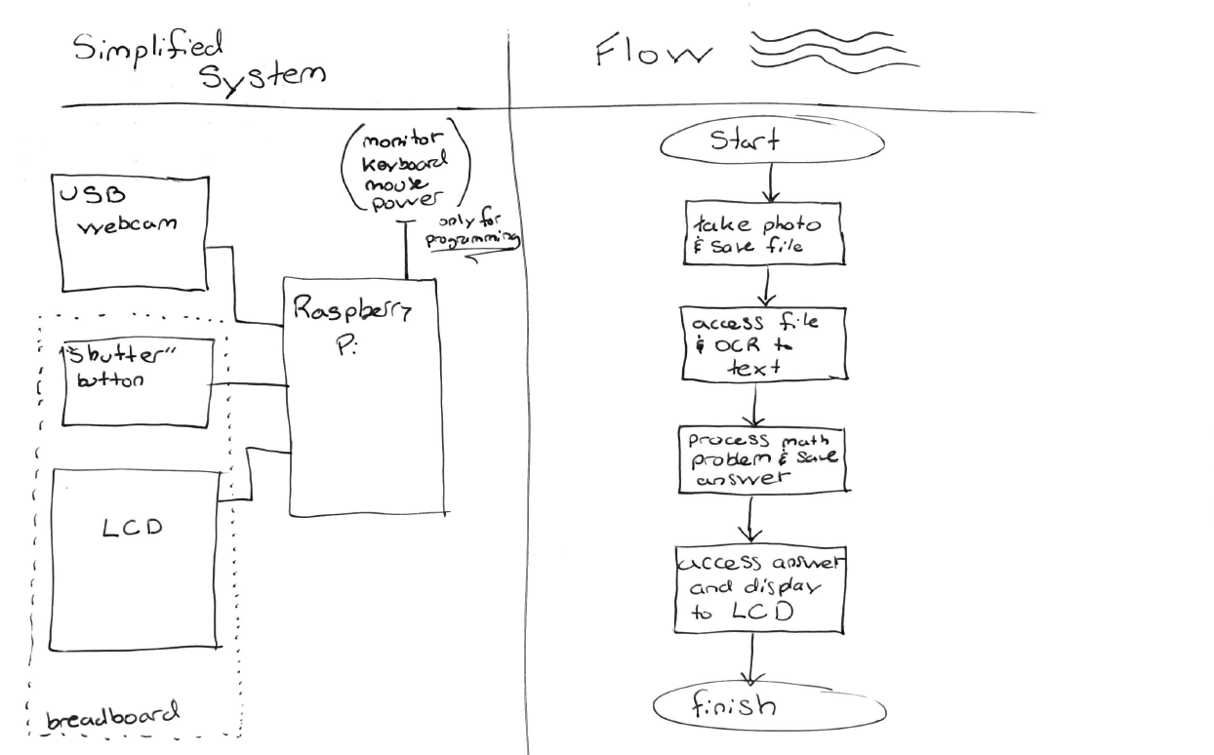

The nuance:

* From what I’ve looked up so far there’s a Linux library called Tesseract (Avengers?) that does really well with image processing. Could use something else if it’s better / easier.
* Main complaint I’ve seen about Tesseract is the font used. Seems it can have issues with blocky fonts so we may need to play around with bold round fonts to see what’s most reliable.
* This flow looks a lot like a finite state machine with the button simply acting as a reset. Maybe start in the final do nothing, change nothing state and the button will reset to the first state which begins taking the photo.
* May need to play with delays between states as Image processing isn’t quite as near-instant as the rest of the states.
* Will need to coordinate input and output file types to be sure we’re not writing stages that use the wrong test types and don’t mesh together.
* I’ve also seen fswebcam is a good linux library for taking and saving photos via USB webcam